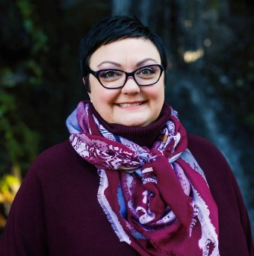
Leatte Dahlhoff
Leatta Dahlhoff is a chemist, environmentalist, and community advocate dedicated to improving the lives of the people of Tumwater and our great South Sound community. Her mission is to protect, preserve, and enhance Washington's environment, and promote the wise management of our air, land, and water for the benefit of current and future generations. She is a former ICSEW member, Chair, and served on the Legislative Committee, and is an environmental technical analyst with the Department of Enterprise.

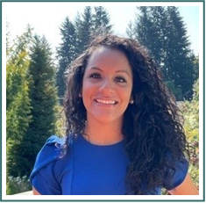
Josefina Magaña M.A., PMP, CDMS
Josefina Magaña makes an impact wherever she goes through purpose, empowerment, and connection. She is an innovator who is not afraid to show up and get the job done. She is the current Director of Thurston Thrives, a community collective health impact organization.
Prior to joining Thurston Thrives, I worked at the Washington State Department of Labor and Industries keeping Washingtonians safe and working. Josefina served as the Executive Chair for the Governor’s Washington State Interagency Committee of State Employed Women for two years. Prior to being the chair, she served as the mentorship subcommittee chair and planned and launched a six-month mentorship pilot program with over 40 participants from different stage agencies.

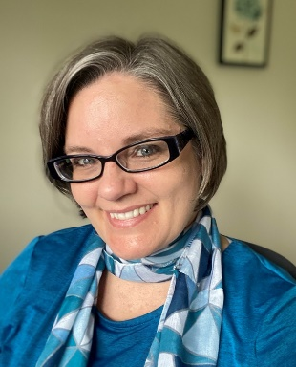
Jhenifer Morfitt
Jhenifer Morfitt currently works as an Employee Development Specialist for the Department of Licensing where she develops eLearning courses and facilitates leadership and diversity, equity, and inclusion training. She served as part of ICSEW from 2010-2015: Conference Subcommittee (2010), Vice Chair (2011) and ICSEW Chair (2012-2015)
In her time as an ICSEW member she experienced the positive impact passionate women have when working together and learned that vulnerability is a strength that builds trust and empowers us to be compassionate leaders. ICSEW also taught her to see the strengths in herself and others.


Keri O’Connell
Keri O’Connell is a Tax Information & Policy Specialist in the Executive Division at the Department of Revenue. She joined ICSEW in July 2020, and currently serves as the co-chair of the Legislation and Policy Subcommittee while also assisting on the Communications Subcommittee.


Jennifer Ward
Jen Ward is an Executive Assistant at Employment Security Department of Washington. She is current on ICSEW’s Membership Committee. During her time as a member, she values the partnership with women from other state agencies and the opportunity that ICSEW has given her to step out of her comfort zone.

