

**Communications**

Worked with Three Girls Media, a woman owned business certified with Office of Minority Women’s Business Enterprises (OMWBE) to complete a website relaunch. Launched website in May.

Site views dipped from March to April when we stopped posting new content in preparation for the launch. Site views between May and June **increased by 52%**

We have 217 blog followers as of June 21, 2021. In the first month of our website launch, we increased 7.3% in blog subscribers. For comparison, we went from 166 followers to 201—a **17.4%** increase in subscribers over an entire year. In the first month of our website relaunch, we’re halfway to surpassing the percentage of change in a shorter amount of time.

Grew our Facebook followers by 6.1% (420 in FY 2020-2021 compared to 394 in FY 2019-2020)

We’ve continued to stream our meetings on Zoom and Facebook Live. I don’t have the Zoom numbers, but for our March 2021 meeting, we had 199 people view it live. People go back to watch sections of meetings.

**Legislative & Policy**

During the 2021 Washington State Legislative Session, the Interagency Committee for State Employed Women (ICSEW) Legislative and Policy Subcommittee tracked 15 bills. Of these bills, twelve of the bills the Legislative and Policy Subcommittee felt were important to our membership passed.

This year, more than 1,000 bills were introduced. There were 486 senate bills and 587 house bills. Of these bills, only 335 passed. This is the lowest total number of bills to pass in a long, 105-day session since 1983.



The Legislative and Policy Subcommittee is currently looking into ways to spread information about bills that are now becoming law that might benefit our members. This includes reaching out to groups like No Problem Period who were instrumental in the passage of HB 1273 – Berg – Menstrual Products in Schools to determine how our membership can assist with implementation of drives for menstrual products to be donated.

In order to better serve our membership during the interim, the Legislative and Policy Subcommittee will be focusing on engaging in and promoting volunteer opportunities within policy arenas important to our membership, including helping with garden maintenance work at the Thurston County Foodbank and SafePlace.

**The year in review…**

With the onset of the pandemic, the 2020—2021 annual period presented significant challenges for ICSEW. ICSEW adapted by:

•  Moving meetings to a virtual format via zoom to allow for a safe and supportive environment

•  Canceling the 2020 conference

•  Conducting executive board meetings using zoom

•      Removing all training fees to support our members during the COVID pandemic

**Mission: The Interagency Committee of State Employed Women (ICSEW) seeks to better the lives of state employees through advocacy, outreach, opportunity, and by advising the Governor and agencies on policies that affect state-employed women.**

**Interagency Committee for State Employed Women (ICSEW)**

**July 2020 – June 2021 Annual Report**







**Revenues and Expenditures**

 Due to canceling the 2020 conference, ICSEW did not generate any revenue during the annual period. For expenditures, ICSEW incurred a total of over $17,000 in expenses. Thanks to reserve funds we are financially solvent only spending 13.3%.

|  |  |
| --- | --- |
| **Expenditures** | |
| **Gravity Forms** | $ 59.00 |
| **Misc.** | $ 868.30 |
| **Transformational Coaching** | $ 900.00 |
| **Zoom** | $ 2,186.91 |
| **Three Girls Media** | $ 13,500.00 |
| **Total** | **$ 17,514.21** |

The contract with Three Girls Media comprised the majority of ICSEW’s expenses. As a result, 77% of ICSEW’s business was done with a certified women business enterprise

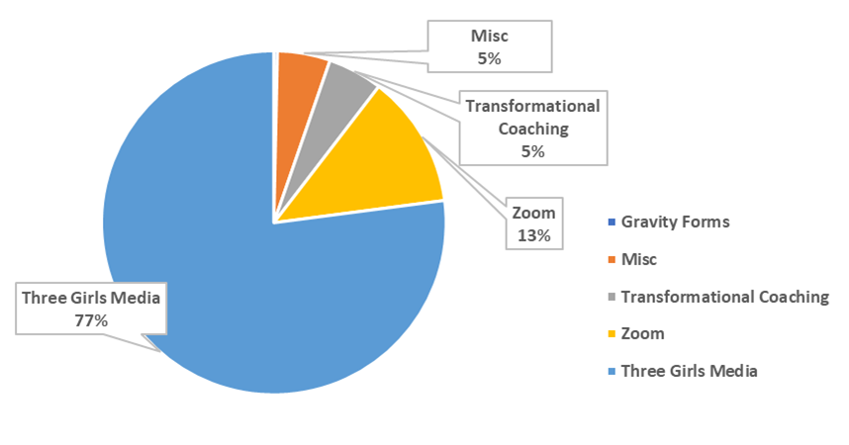

**Interagency Committee for State Employed Women (ICSEW)**

**July 2020 – June 2021 Annual Report**

**Wellness**

**Partnerships Subcommittee**

Continued to Coordinate with the Business Resource Groups (BRGs) – activities included:

* + Inviting the BRGs to present at ICSEW’s upcoming 2021 Conference
  + Arranging BRG speakers for ICSEW general meetings
  + Maintaining lines of communication during the COVID-19 pandemic

In addition, Partnerships Connected with Regina Malveaux, Director of the Washington State Women’s Commission, and presented data on COVID-19’s impact on female identifying state employees during the Commission’s June plenary session.

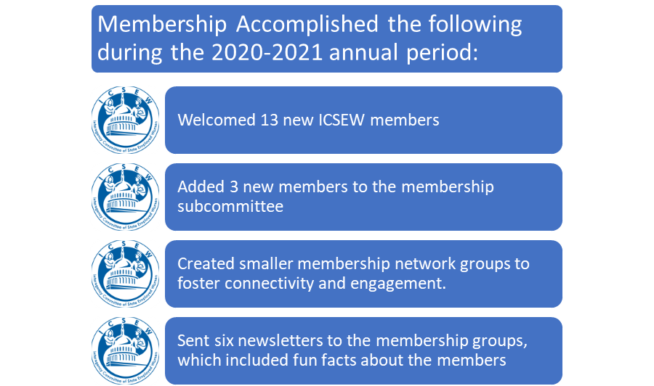

**Public Outreach Subcommittee**

During the past year, the Public Outreach Committee focused on wellness. The Committee organized an upcoming ICSEW membership meeting focused entirely on wellness topics such as financial wellness, physical wellness, and emotional wellness.

The Committee ran its annual charity drive to support organizations that help survivors of domestic violence. This was even more crucial this year as COVID-19 shelter in place orders kept victims of domestic violence in close proximity to their abusers. The Committee expanded the annual charity drive from a single organization to a statewide effort supporting 8 locations across Washington and created a system for donating that met social distancing requirements while giving easier access to individuals and businesses to participate. This allowed people to make a difference twice with one donation, helping a family or individual in need as well as a local business owner. Feedback on the drive was positive and plans to expand to a hybrid model in the future is in the works.

**Membership**



**Mentorships Subcommittee**

The Mentorship subcommittee manages the development of the mentoring program as well as the resources that facilitate it, including the application process, orientation, and evaluation. During the past year, Mentorships piloted its mentor program.

Overall, 38 people participated in the pilot for a six month period. Some of the lessons include:

* Mentors saw Mentees as good learners, open to feedback
* Follow-up from Mentors and mentees needs improvement--especially from Mentors
* Mentees rated mentors somewhat better than (mentors rated mentees) in communication
* Mentee’s evaluation of mentor’s skill had a wide range which suggests more training for mentors is needed.
* Most pairings met every 2-4 weeks were considered accessible overall.
* Overall experience was excellent for mentees and good to excellent for mentors

**Next steps for moving forward with the program include:**

* Developing full evaluation report
  + Committee feedback review
  + Employee Engagement Results
  + Diversity, Equity, and Inclusion
* Presenting to ICSEW Board
* Presenting to additional stakeholders such as the Governor’s Office and OFM

**Professional Development Subcommittee**

The Professional Development Subcommittee organizes workshops and training as well as networking opportunities for our membership. Collaborating with the Women’s Commission and the Partnerships Subcommittee we will organize the upcoming ICSEW 2021 Conference.

**Interagency Committee for State Employed Women (ICSEW)**

**July 2020 – June 2021 Annual Report**

**July 2020 to May 2021** **General Membership Meetings and Trainings**

*Open to Representatives, Alternates, and the General Public*

|  |  |
| --- | --- |
| **JUL** | Annual celebration with Dr. Karen Johnson as the keynote speaker. |
| **AUG** | * Visuals in a Virtual Meeting – Lisa Arora * Power of Inclusive Presence – Larisa Benson |
| **SEP** | * “The Partnering for an Inclusive Workforce Project” by What’s Next Washington, Susan Mason and Rosalyn Solomon * “Preventing Cybercrimes & Data-Mining for State Employees” by Kim Triplett-Kolerich |
| **NOV** | * **Overview of the Legislative process**, presented by Joanna Eide |
| **JAN** | * How to Survive, Revive and Thrive Professionally in a Crisis, presented by Anne Hiatt * **Building Resilience to Manage Stress** - Employee Assistance Program – Kari Uhlman * **Washington State Women’s Commission (WSWC)** Update by Regina Malveaux |
| **MAR** | * **Burn Out** - Jared Bull and Linda Tilson presented on burnout and strategies to become more resilient. * **Coping with COVID in the Workplace** – Dr. Tona McGuire, DOH |
| **MAY** | * **Building and Maintaining a Culture of Transformational Leaders** presented by Linda Tilson and Jared Bull |

**ICSEW Leadership**

|  |  |
| --- | --- |
| ICSEW Chair | Josefina Magana |
| ICSEW Vice-Chair | **Lu Eyles** |
| Treasurer | **Christina Steward** |
| Executive Secretaries | **Sequenna Fashana**  **Rachael Hopkins-Friesner** |
| Communications Chair | **Rachel Friederich** |
| Legislative & Policy  Co-Chairs | **Deirdre Bissonnette**  **Leslie Wolff** |
| Membership Chair | **Marianne McIntosh** |
| Professional Development Chair | **Marie Splaine** |
| Partnerships Co-Chairs | **Melissa Harris**  **Allison Spector** |
| Public Outreach Co-chairs | **Jasmine Pippin-Timco**  **Debra Lefing** |